

Job Description
Partnerships and Philanthropy Lead

Job Title: Partnerships and Philanthropy Lead
Reporting to: Director of Fundraising
Responsible for: Senior Partnerships & Philanthropy Officer, external consultants and agencies
Based: We offer a hybrid model of working and our office is based
in Angel, London N1. This postholder is expected to be in the
office 1 day per week and be able to regularly attend events and meetings in Central London and other locations with our partners.
We meet together in our London office monthly
on Tuesdays and we ask that you can commit to this.

Hours: Full time – 35 hours
Salary: Grade 5 (£54,651 to £56,563)
Travel expenses: All staff are required to pay for travel costs to and from the London office, regardless of where they live. However, staff can claim travel expenses for journeys to places other than the London office for work purposes.

About us

Young Women’s Trust champions young women on low or no pay. We’re here to create a more equal world of work and raise young women’s incomes. We tackle sexism and misogyny, with and for anyone who has experienced this.

We offer young women free coaching, feedback on job applications and information to help them get where they want to be. We bring together a thousands-strong network to support each other, build their self-belief, and have their voices heard. We work with young women and anyone who experiences misogyny and sexism to campaign for equality in the workplace. And our research provides insight into what young women’s lives are really like, fuelling our campaigns for change.

About the role
The Partnerships and Philanthropy Lead is responsible for growing and diversifying Young Women's Trust's income through corporate partnerships, major donors, and trusts & foundations, securing the funding that powers our mission to create a more equal world of work for young women.
You will play a critical part in delivering our new organisational strategy, building and developing an area that already contributes the majority of our fundraised income. You'll strengthen our approach to relationship-led fundraising and create new partnerships that will sustain our growth.
You will bring a track record of securing significant income from corporate partners, major donors or trusts & foundations, with demonstrable success in building and growing high-value relationships. You'll be passionate about connecting funders to the cause of young women's equality, and will have the ability to build influential relationships and represent Young Women's Trust with a range of external audiences.

Key deliverables

- Lead the P&P fundraising function, working closely with the Director of Fundraising to develop and implement the Fundraising strategy and annual operational plan.
- Deliver agreed annual fundraising targets in line with organisational budgets and key performance indicators (KPIs).
- Build and nurture relationships with existing partners and individual stakeholders, ensuring first-class stewardship and long-term engagement.
- Identify and secure new business opportunities, developing long-term, strategic relationships across all philanthropy and partnership audiences.
- Design, test, and implement innovative propositions and products to engage corporate partners and high-value donors.

Main responsibilities

- Take lead responsibility for the P&P function, working with the Director of Fundraising to set the approach and propose annual plans to maximise engagement and income.
- Design and execute innovative cultivation and stewardship strategies to engage and retain major donors, trusts, foundations, and corporate partners.
- Develop and deliver high-impact partnerships that align with key organisational priorities, including policy influence, service development, and operational effectiveness.
- Identify, research, and secure new business opportunities by building and maintaining a robust pipeline of prospective partners and key stakeholders.
- Lead on compelling pitches, proposal development, and contract negotiations to secure multi-year strategic partnerships
- Oversee the creation of high-quality fundraising materials, impact reports, and strategic partnership communications.
- Work closely with our internal Communications, Campaigns and Research team to develop and manage brand partnerships, media relationships, and engagement with key journalists, influencers, celebrities, and their representatives
- Proactively assess and mitigate reputational risks associated with corporate and philanthropic partnerships, providing guidance to the Director of Fundraising, SLT, and CEO as required.
- Manage the budget for this function, tracking expenditure and restricted income, and ensuring targets are met.
- Line manage the Senior Partnerships & Philanthropy Officer and other direct reports as the team grows, providing leadership and professional development.
- Contribute fully to the fundraising management team, taking the lead on key cross-team and cross-organisational activities.
- Ensure all fundraising activities adhere to relevant legal, regulatory, and ethical standards.
- Maintain accurate records using our CRM system and report on fundraising performance.
- Lead and contribute to the development and continuous improvement of fundraising policies, procedures, and best practice.

Budget management

Responsible for co-developing budgets with the Director of Fundraising, able to sign off on invoices under £1000.

General responsibilities

- To work in a flexible manner, taking initiative and prioritising the needs of the organisation.
- Follow organisation policies and procedures, including health and safety.
- Carry out other reasonable duties that may be required.
- Act as champion of Young Women’s Trust’s values and principles, including our commitment to becoming an anti-racist organisation.

Special factors

To work out of hours on occasion to attend events both on weekday evenings and weekends (with time off in lieu given).

Safeguarding

At Young Women’s Trust, we are committed to safeguarding the well-being of all the young women we work with, as well as our employees and volunteers who are involved in or affected by our work. All employees have a duty to prevent the abuse of children and adults and report any safeguarding concerns to the relevant person.

DBS requirement

N/A

Equity, Diversity and Inclusion

Young Women’s Trust strives to be an inclusive and representative organisation. We are committed to appointing individuals from a wide range of backgrounds, lived experiences and cultures. We particularly encourage applications from communities under-represented in our organisation and we use positive action under section 159 of the Equality Act in relation to race. This means that if we have two candidates of equal merit in our process, we will seek to take forward the racially minoritized candidate in order to diversity our staff team.

You’ll be joining a team that will embrace your ideas and support and encourage you to bring your whole self to work.

We can make reasonable adjustments throughout the application process and on the job. If you have particular accessibility needs, please get in touch and let us know any requirements you may have.

Person Specification

(Essential, i.e., a candidate must meet all essential criteria to be considered for selection, or Desirable)

Experience | Essential | Desirable
- A significant track record of developing relationships with corporate prospects, partners and senior stakeholders up to CEO level | x
- Proven track record of securing six- and seven-figure partnerships / gifts from corporate partners and ideally major donors | x
- Experience of securing strategic grants from trusts and foundations |  | x
- Strong cultivation and stewardship experience, understanding the needs of potential and existing partners | x
- Strong experience of budgeting, forecasting and reporting | x
- A track record of leading work across teams – able to influence and mobilise internal stakeholders to secure and sustain long-term high value support | x
- Experience in using Salesforce |  | x
Skills & attributes

- Strong relationship management skills, with experience in engaging and influencing senior stakeholders | x
- Flexible, creative and collaborative approach to work, able and willing to both lead and be a very ‘hands on’ member of the team | x
- Outward facing – knowledge of fundraising trends, techniques, and best practice in corporate partnership and philanthropic fundraising | x
- Excellent verbal communicator with a wide range of individuals including CEOs, other senior leaders and young women | x
- Excellent written communication skills, with a demonstrable experience of developing and writing persuasive funding applications and partnership proposals | x
- Line management skills – set and managing objectives, coach and support direct reports to ensure professional development | x
- Understanding of the issues facing young women, especially those living on low or no pay |  | x
- A commitment to Young Women’s Trust’s values and principles, including our anti-racism work | x

Our values

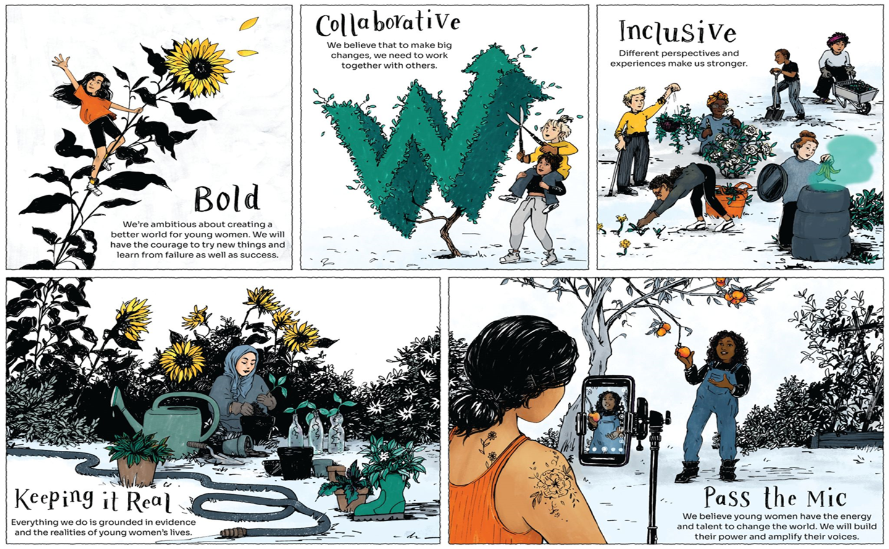
Young Women’s Trust Structure [August 2026]

